ASSIGNMENT NO 5

Nirbhay Ahir

[Nirbhay.ahir36@gmail.com](mailto:Nirbhay.ahir36@gmail.com)

1. What does an empty dictionary's code look like?

Ans: Dictionary is written using {} and key value pairs are passed inside this. Therefore an empty dictionary will look like as follows

Dict = {}

2. What is the value of a dictionary value with the key 'foo' and the value 42?

Ans: {‘foo’ : 42}

3. What is the most significant distinction between a dictionary and a list?

Ans: Representation wise lists are represented by [] whereas dictionary is represented by {}.

Items in the lists are ordered while in dictionary they are unordered.

List store single value as an element while dictionary stores key value pair data.

4. What happens if you try to access spam['foo'] if spam is {'bar': 100}?

Ans: We will get a key error as follows

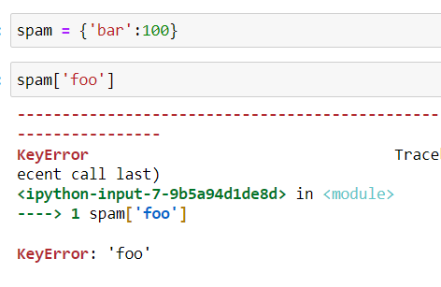

5. If a dictionary is stored in spam, what is the difference between the expressions 'cat' in spam and 'cat' in spam.keys()?

Ans: There is no difference in both the expressions as both will give the same output if ‘cat’ is present in dict spam.

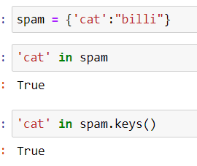

6. If a dictionary is stored in spam, what is the difference between the expressions 'cat' in spam and 'cat' in spam.values()?

Ans: ‘cat’ in spam will check if there exists a key named ‘cat’ in the dict named spam whereas ‘cat’ in values will check if there exists a value named ‘cat’ in dict named spam.

7. What is a shortcut for the following code?

if 'color' not in spam:

spam['color'] = 'black'

Ans: This output can be achieved using spam.default() as follows

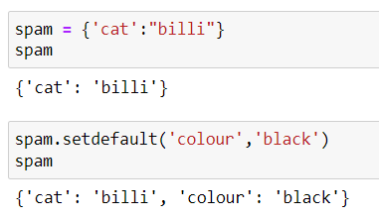

8. How do you "pretty print" dictionary values using which module and function?

Ans: Pretty print can be done importing the pprint module in python. Pprint simply presents the dict in more readable way.

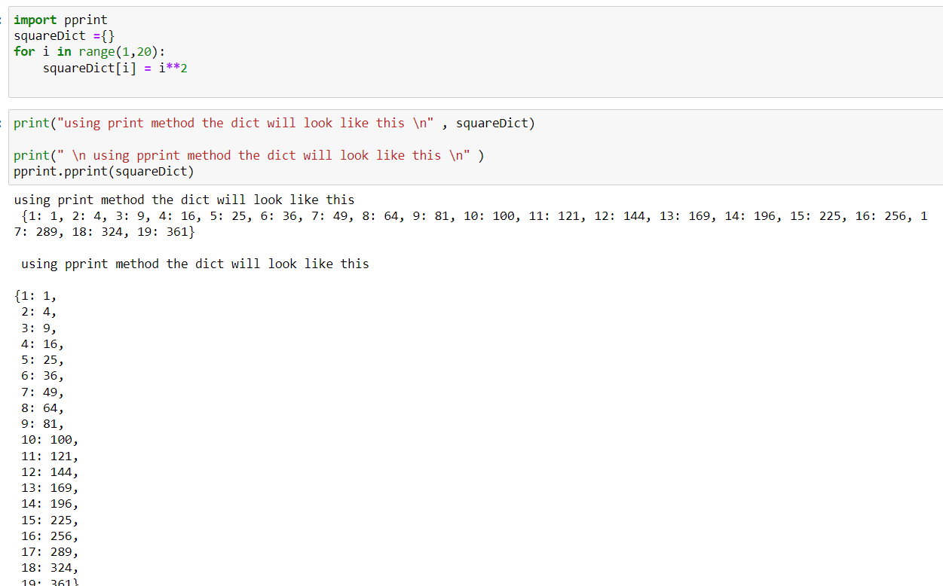

pprint does not prettify nested dictionary.

